SUBMISSION FOR SQL TASK 3

Name: Eng Zhi Cheng

Class: 1K4

Topic: SQL TASK 3 (10% CARRYMARK)

Date : 16 December 2024

_________________________________________________________________________  
SQL Command for making database:  
CREATE DATABASE db_library

Screenshot of results:



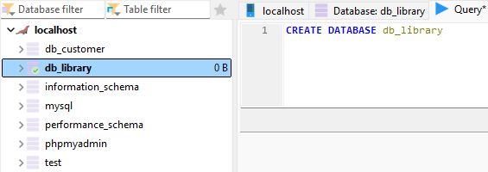

SQL Command for making table:

CREATE TABLE books (

book_id INTEGER PRIMARY KEY,

title VARCHAR(255) NOT NULL,

author VARCHAR(255) NOT NULL,

borrowed_date DATE

);  
  
Screenshot of results:  
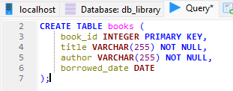

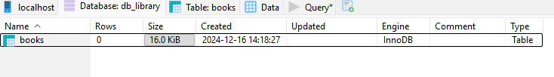

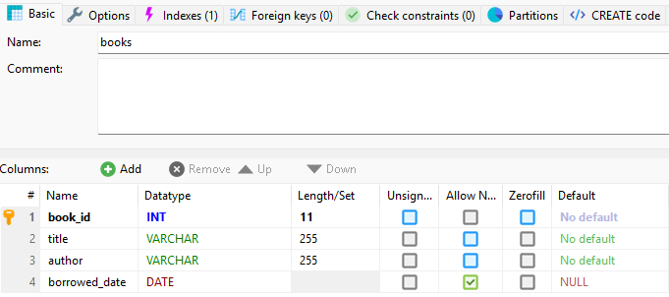

SQL Command for inserting books (I redid the commands because it kept saying error):

USE db_library;

DROP TABLE IF EXISTS books;

CREATE TABLE books (

book_id INTEGER PRIMARY KEY AUTO_INCREMENT,

title VARCHAR(255) NOT NULL,

author VARCHAR(255) NOT NULL,

borrowed_date DATE

);

INSERT INTO books (title, author, borrowed_date) VALUES

('To Kill a Mockingbird', 'Harper Lee', '2024-02-15'),

('1984', 'George Orwell', '2024-01-22'),

('Pride and Prejudice', 'Jane Austen', '2024-03-10'),

('The Great Gatsby', 'F. Scott Fitzgerald', '2024-02-28'),

('Brave New World', 'Aldous Huxley', '2024-01-05');

Screenshot of results:

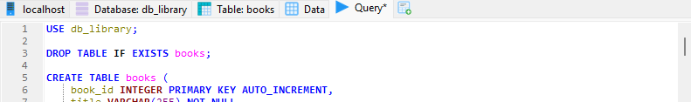

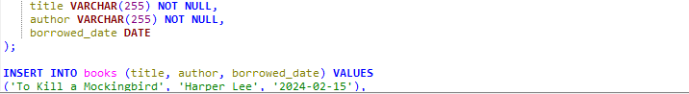

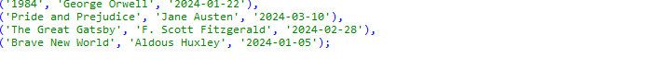

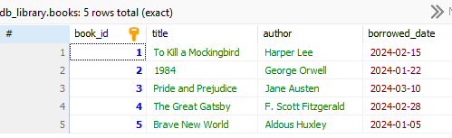

SQL Command for Basic Queries (selecting books):

SELECT * FROM books;

SELECT * FROM books WHERE author = 'George Orwell';

SELECT * FROM books WHERE borrowed_date = '2024-02-15';

SELECT * FROM books WHERE borrowed_date > '2024-02-01';

Screenshot of results:

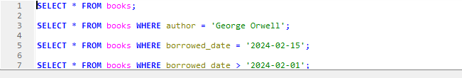

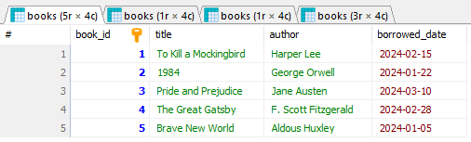

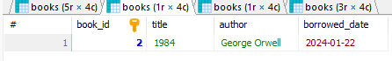

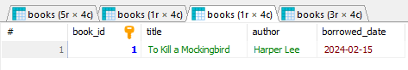

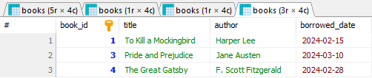

SQL Command for Data Manipulation:

UPDATE books

SET borrowed_date = '2024-04-01'

WHERE book_id = 1;

DELETE FROM books

WHERE book_id = 2;

INSERT INTO books (title, author, borrowed_date)

VALUES ('1984', 'George Orwell', '2024-04-15');

Screenshot of results:

